Emotion, body and mind across a continent: Figurative representations of emotions in Australian Aboriginal languages.
Special Issue of Pragmatics and Cognition. Edited by Maïa Ponsonnet, Dorothea Hoffmann & Isabel O’Keeffe.
Dorothea Hoffmann, University of Oregon.
dorothea@uoregon.edu

Title: Be happy when your stomach is: The body as emotion metaphor in MalakMalak

ABSTRACT

In this paper I provide a description of the role of body-part terms in expressions of emotion and elsewhere in MalakMalak, a non-Pama-Nyungan language of the Daly River area. Body-based expressions denote events, emotions, personality traits, significant places and people and are used to refer to times and number. Particularly central in the language are men ‘stomach’, pundu ‘head’ and tjewurr ‘ear’ associated respectively with basic emotions, states of mind and reason. Noun incorporation is a central part of forming predicates with body-parts, but uncommon in any other semantic domain of the language and only lexemes denoting basic emotions may also incorporate closed-class adjectives.

Keywords: MalakMalak, language of emotion, parts of speech, cultural salience

1. Introduction

This paper investigates the lexicon of emotion in MalakMalak, a non-Pama-Nyungan Northern Daly language, with particular emphasis on the body-part derived lexemes. Overall 75 emotion lexemes are recorded in the language. Out of these, 29 are body-based expressions. The majority of these (21) are coverbs, with the body-part term incorporated at the first position of the word. Of the remaining lexemes, three are simple coverbs related to body part nouns, four are adjectival phrases denoting body-part related insults that may cause emotional reactions, and one is a complex phrase that encodes the notion of ‘homesickness’. The 24 coverbs all may form part of complex predicates while the phrases stand alone.
Nine different body parts are used in the emotion lexicon. These are the stomach/belly, eyes, teeth, head/brain, buttocks, nose, leg, foot, and ear. Following, I first introduce the language and some noteworthy grammatical features in section 2. Section 3 presents the diversity of the semantic domains where body parts have semantic extensions. In section 4, I present the figurative extensions of body parts in the emotional and cognitive domain. In section 5, I discuss noun incorporation constructions and other body-part specific constructions, and how they may result from the figurative nature of the collocations, and therefore from the figurative potential of body parts.

2. The language

MalakMalak is a non-Pama-Nyungan Northern Daly language. Today, five elderly speakers remain in the community of Woolianna, by the Daly River, and the communities Fifteen Mile and Belyuen. Children no longer actively acquire the language but some early revitalization efforts are currently in planning stages.
MalakMalak has ‘free’ word order with regards to syntactic ordering, double-marking and an optional case-marking system for ergative/absolutive case. Finally, there is a limited optional nominal classification system.

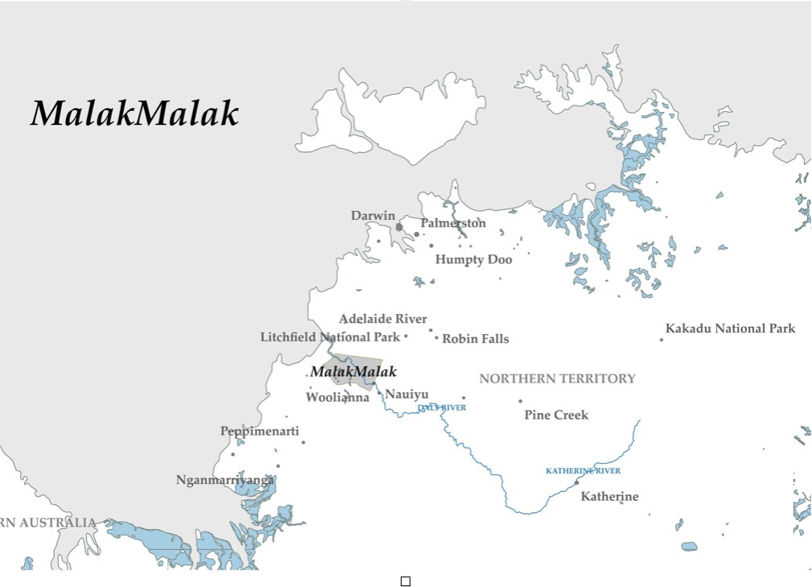
Map 1: The location of MalakMalak

Particularly noteworthy for this investigation are MalakMalak’s multi-verb constructions, namely, complex predicates alongside and intermingling with serial and compound coverb constructions. Complex predicate constructions are a common feature of languages across Australia’s Top End including Jaminjung (Schultze-Berndt 2000) and Gija (Kofod & Crane this volume). The complex predicates consist of an inflecting verb from a closed class while the coverbs are uninflecting and form an open class. In MalakMalak, only six inflecting verbs are recorded, glossed as ‘do’, ‘sit’, ‘lie’, ‘stand’, ‘move/be’ and ‘move (with purpose)’. The latter inflecting verb is disappearing from the language and appears to be only used in set phrases today. In complex predicate constructions inflecting verbs can either precede (rare) or follow the coverb. All except one of the inflecting verbs (transitive ‘do’) can occur on their own as well as in complex predicate constructions. The inflecting verbs are marked for person, number and gender (for 3rd person singular only) as well as tense/aspect. Coverbs take two aspectual suffixes for continuative and perfective but no other inflectional marking. Similar to what has been described for Gija (Kofod & Crane this volume), a small number of lexemes can be both nouns and coverbs.
Example (1), from a dreamtime narrative, illustrates MalakMalak’s various multi-verb constructions remarkably well. The complex predicate ka yida combines a single coverb ‘come’ with an inflecting verb ‘he went’ to form the phrase ‘he came here’. Two compound coverbs kubuk-kararr and dat-tjed form a serial coverb construction within the complex predicate that includes the inflecting verb yuyu ‘s/he stood’. Compound coverbs denote single events such as kubuk-kararr swim-move.up, ‘cross a river’ and dat-tjed see-stand, ‘look out’. Serial coverb constructions on the other hand encode a series of related sub-events within one complex predicate construction.

(1) | kubukkararr dattjed yuyu yanak, ka yidake
 | kubuk-kararr | dat-tjed | yu-yu | yanak | ka | yi-da=ke
 | swim-move.up | see-stand | 3sg.m-stand.pst | one | come | 3sg.m-go/be.pst=foc
 | ‘he crossed the river and looked once, then he came here’ (DH13_A35_02.161)

All data for this investigation is based on the author’s fieldwork (Hoffmann 2017), a draft dictionary (Hoffmann et al. 2017), and older recordings transcribed and translated by the author (Crocombe 2010, Birk 1974). My primary interests in documenting MalakMalak revolved around the language of space (Hoffmann 2019, 2013) and more “general” goals of documentation such as workable dictionary and sketch grammar. Consequently, I never used specific stimuli to elicit terms of emotion.

3. The figurative scope of body parts

It has been argued (Wierzbicka 1999, Hupka et al. 1996) that the meanings of emotional expressions are not universal, “because all concepts of emotions are culturally based. What an Englishman labels as ‘anger’ is not exactly the same feeling as what an Italian means by ‘rabbia’” (Niemeier & Dirven, 1997:ix in Wierzbicka 1999). This kind of variation also exists between varieties of one language as Sharifan (2017:85) notes in Foolen (2017:3) for Aboriginal English where “the word sorry can be used for emotions having to do with ‘mourning’ and/or ‘empathy/care’.” Ponsonnet (2018: 118-119) similarly notes for Barunga Kriol that “while wori alone can indeed mean ‘be preoccupied’, wori+DAT means ‘miss, grieve’, and a better gloss for wori is the more generic ‘feel bad about a beloved person (missing, grieving...)’”
Body parts play a central role not only in expressions of emotion but elsewhere in areas of high cultural salience. Gaby (2008) describes intricate relations between physical, spiritual and emotional health as well as the relationships between the natural external world and the internal physical world. She states (2008:39):

the Thaayorre language is filled with metaphors that describe the natural world in terms of the human body. the pungk ‘knee’ is thus invoked in the description of other angular projections, such as ngok pungk ‘water knee = waves’, or may have spiritual significance as in raak pungk ‘place knee = tribal lands’. The branches of a tree are described as punth ‘arms’. ... The description of mental, emotional and spiritual experiences in terms of body parts fits within this broader understanding of the external world in corporeal terms.” (Gaby, 2008, 39)

MalakMalak makes similar connections and body parts play a central role in culturally significant semantic domains including but not limited to emotional metaphors. The natural and spiritual world may be described with metaphors of the human body. These cover a number of domains. Firstly, placenames as in (2) often include the term for ‘nose’ (2a) and form compound nouns (2a) or compound coverbs with body-part-term noun incorporation (2b).

(2) a. Yininy-delik
nose-cane.grass
‘place name, where the cane grass grows’
b. Tjiny-bain-gitj
buttocks-change.location-throw
‘place name, where things change’

Secondly, times of year, specifically, seasons as in (3) and times of day (4) may also include body part terms in compound nouns.

(3) a. pundu-miri
head-sun
‘buildup season’
b. punggul-lerrp
knee-hot
‘early dry season’

(4) a. miri-pundu-tjalmiyen
sun-head-right/straight
‘noon’
b. miri-ngarrik
sun-cheek
‘afternoon’

Thirdly, there are a number of nouns that have multiple meanings as body parts and landscape or features of the natural world. Gaby (2008) describes these for Kuuk Thaayoore and they are also found in French, German or English in expressions such as the foot of the mountain or mouth of the river. This category includes cross-linguistically common synonyms such as wurru for ‘arm, tree and river branch’ in (5b) and iconic connections such as dawud ‘blood, sap’ (5a) and describing the mouth and spring of the river as ‘foot’ and ‘throat’ respectively (5d) and (5e).

(5) | a. | dawud | ‘blood; sap’
 | b. | wuru | ‘arm; tree branch; river branch’
 | c. | payak | ‘back; riverbank; island’
 | d. | matjan | ‘foot; mouth of river, downstream (place)’
 | e. | menyik | ‘throat; spring of river, upstream (place)’
 | f. | did | ‘tooth; stick; riverbank’

Thirdly, similar to the above-mentioned nouns with multiple meanings, a few terms in MalakMalak denote body parts as well as items of high cultural salience such as fishing hooks and seeds (6). The analogy of ‘seed’ and ‘eye’ is widespread across Australia and attested worldwide (Brown & Witkowski 1981:600-601).

(6) a. yininy/yiny ‘nose; fishing hook’
b. numurru ‘eye, seed’

Related to this domain are compound nouns encoding spiritual leaders such as ‘witch doctor’ in (7).

(8) numurru-dagil
eye-lightening
‘bush doctor, witch doctor, shaman’

Finally, body part terms may form parts of multiplicative numerals as in (9) or can be used as quantifiers as in (10).

(9) a. wurru-yanak
arm-one
‘once’
b. wurru-werena
arm-two
‘twice’ etc.

(10) pundu ‘head; full, whole’;

Overall, lexemes related to body parts are of fundamental importance in many aspects of MalakMalak traditional life. In addition to emotions that will be discussed in more detail in the remainder of the paper they denote significant places and times of year or day as well as culturally salient landscape features and items in the natural and spiritual world. Body parts exhibit rich semantic extensions in most languages across the world, but in MalakMalak perhaps even more than some others. There are some reasons to think that this property may be shared by a number of Australian languages such as Kuuk Thaayoore (Gaby 2008) mentioned above. Walsh (1987:432-433) analyses impersonal verb constructions in a number of Australian languages typically describing “bodily or mental states”. Further research may explore whether this correlates with some culturally specific view to construe and/or relate to the body in MalakMalak and other languages.
This area of research forms part of neo-Whorfian ideas as investigated by various authors (Levinson 2003, Levinson & Wilkins 2006, Levinson & Gumperz 1996, Lucy 1992, 1996, Pederson et al. 1998, Danziger 2010, 2001) highlighting the “correlations between language, culture and thought, exploring in particular how language may or may not reflect cultural trends” (Enfield 2002).

4. Body parts in figurative descriptions of emotion

There are seventy-five recorded emotion terms in MalakMalak (Hoffmann et al., 2017). Of the forty-three coverbs, there are 29 body-part expressions. Example (2) shows some examples of coverbs that are not body-part derived, including simple coverbs such as (11a), reduplicated coverbs (11b) and compound coverbs (11c).

(11) | (a) | luk
 |  | ‘happy’
 | (b) | luk-luk
 |  | ‘very happy’
 | (c) | lam-dam
 |  | talk-unable/stop
 |  | ‘brood’

Reduplicated coverbs intensify the meaning of the base coverb as in (11b) and the meaning of many compound coverbs is evocative of emotion as in 11c) and (12). In (11c) not talking or being unable to do so denotes the emotional event of “brooding” and in (12) throwing oneself around happily encodes excitement. Mostly, these coverbs form parts of complex predicates with inflecting verbs (Hoffmann, 2015). An example is (12) where the inflecting verb ‘he is sitting’ adds the meaning of duration to the described event.

(12) | luklukkatj yininginy
 | luk-luk-katj | yi-ninginy
 | rdp-happy-throw | 3sg.m-sit.ipfv
 | ‘he is excited’ (Hoffmann et al., 2017)

There are four terms using coverbs denoting properties and actions of body-parts in compound coverbs. In (13a) wuny denotes a lack of physical sensation or feeling and in (13b) tjing encodes a somewhat troubled and out-of-the-ordinary state of mind.

(13) | (a) | wunytjang
 |  | wuny-tja-ang
 |  | numb-stop-give
 |  | ‘frustrated, stressed’
 | (b) | tjingbany
 |  | tjing-bany
 |  | not.be.in.the.right.mind-change
 |  | worry, worried’

Of particular interest to this paper are 29 body-part derived terms. All are listed in the appendix organized by type of body part. An example is (14).

(14) tjiny-ang-pak
buttocks-give-sit
‘boring, bored’

Only these body-part derived terms will be discussed in detail in the following sections of the paper.

3.1. Categories of body part lexemes

In MalakMalak nine body parts form part of emotion expressions. These are the stomach/belly, head, leg, eye, foot, buttocks, teeth, heart and nose. The ear is furthermore associated with knowledge and reason. As shown in Figure 1, in the language the entire body from head (teeth, nose, eye, brain/head) over the mid-section (heart, belly, buttocks) to toe (leg, feet) finds its way into the emotion metaphor repertoire.

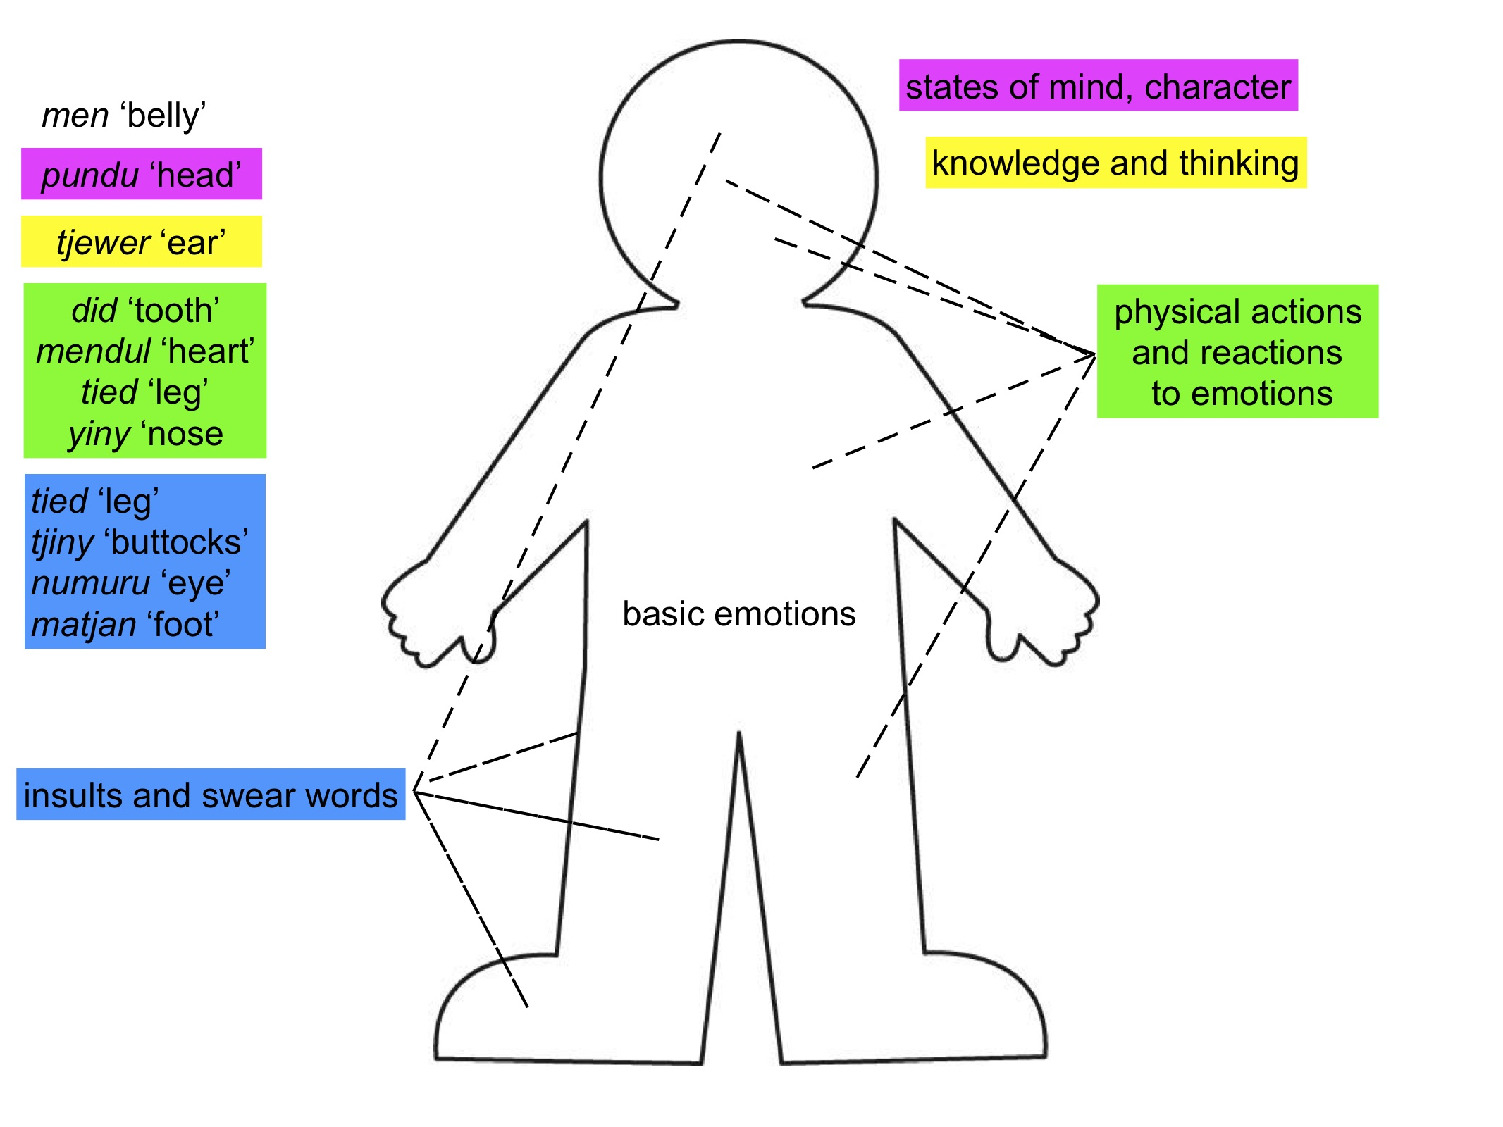
Figure 1: Body parts and emotions in MalakMalak

The body part derived emotion terms cover five distinct semantic categories illustrated in Figure 1. Basic and relatively fleeting emotions are centered in the middle of the body in the belly as exemplified in (15). States of mind, character traits and knowledge are located around the head as in (17), (18) and (25) while insults and swear words as well as physical actions and reactions spread out all over the body, examples (19)-(24). In the following paragraphs I discuss each semantic category in turn.

The lexeme men ‘stomach’ is used to denote ‘basic’ emotions that are not based on reason. The same has been observed for Kujatja (Peile, 1997:63) and Kaytetye (Turpin, 2002:299). At the most fundamental level, a good belly denotes happiness and satisfaction (15a) whereas a bad one leads to unhappiness (15b) and (15c). The belly is the seat of emotions as described for numerous other Australian languages (Ponsonnet 2016, Laginha & Ponsonnet, this volume) including Gija (Kofod & Crane this volume).

(15) | (a) | menpuritj
 |  | men-puritj
 |  | stomach-be.good
 |  | ‘satisfied, happy, lit. stomach is good’
 | (b) | menwunettjed
 |  | men-wu-net-tjed
 |  | stomach-3sg.n-bad-stand
 |  | ‘unhappy, lit. stomach is bad’
 | (c) | menwunettjed dek nga ngunynana
 |  | men-wu-net-tjed | dek | nga | nguny-nana
 |  | stomach-3sg.n-bad-stand | place | 1sg.nom | dist-loc
 |  | ‘(I am) homesick, lit. my stomach is bad when I am in a far-away place.’

Additionally, the pleasant physical sensation of a belly that has not been bothersome for a long time is associated with a positive emotional reaction as in (16).

(16) | men-wuny-pain-wai
 | stomach-numb-good-dur
 | ‘happily surprised, lit. a numb feeling of the stomach turns out to be good’

The belly has been identified as the most widespread body part used in expressions of emotion (Ponsonnet & Laghina, this volume). Its most common meanings are generic positive, negative or neutral emotions (Laginha & Ponsonnet, this volume). In MalakMalak, the belly is figuratively depicted as the seat of emotions as has been observed for 26 Australian languages ( Ponsonnet & Laghina this volume). The significance of the belly in Aboriginal culture may be related ‘to the Aboriginal worldview, in which food has a significant role in determining spiritual and physical health. The place of the food, i.e. the belly, is also connected to spiritual and physical health’ (Sharifian et al. 2008:14)
There are four expressions with men ‘belly’ denoting emotion in the MalakMalak lexicon. They are exemplified in (15) and (16) above and denote two positive and negative emotions each. Two of the tropes identified by Ponsonnet and Laginha (this volume) are attested for the belly-related emotion expressions. All exemplified in (15) are generic metonymies, i.e. the belly is described as either good or bad. The expression in example (16) is a case of somatic metonymy where the physiological state of a body part represents an emotion. A ‘numb belly’ denotes a feeling of surprise and in this example it is furthermore specified that the feeling of numbness is good and lasting for a ‘happy surprise’.

The second category associated with states of mind and character traits both temporary (17b) and (18c) and permanent (17a), (18a) and (18b) is covered by the lexeme pundu ‘head, brain’. This is the only body part in this category.

(17) | (a) | pundu-net
 |  | head-bad
 |  | ‘crazy’
 | (b) | pundu-net-tjing
 |  | head-bad-not.in.the.right.mind
 |  | ‘intoxicated, drugged’

(18) | (a) | pundu-ngatal
 |  | head-strong/hard
 |  | ‘stubborn’
 | (b) | ngan-pundu-ngatal
 |  | characteristic.of-head-strong/hard
 |  | ‘lazy’
 | (c) | pundu-nget
 |  | head-repair
 |  | ‘drugged, intoxicated’

In addition to the four examples in (17) and (18), there are two more in the lexicon. These are a variation on (17a) pundu-wu-net ‘crazy, demented’ and pundu-yi-net ‘stupid’. With regards to tropes, the expressions in (17) are generic metonymies. Those in (18) are metaphorical denoting physical properties that are not a plausible state of the head. Specifically, its properties are that of resistance with the head described as ‘hard’ or ‘in need of repair’.

The third category includes lexemes describing actions and words that may cause emotional reactions. These include insults (19) and swear words (20). These are rare in the discourse data. In fact, I first came across these expressions during an elicitation session of the semantic domain of insults and swear words.

(19) | (a) | tjed | yin-metj
 |  | leg | 3sg.m-small
 |  | ‘small, skinny leg’
 | (b) | tjiny | mi-tjbi
 |  | buttocks | 3sg.n*-small
 |  | ‘small buttocks
 | (c) | numuru | yi-neret
 |  | eye | 3sg.m-very.bad
 |  | ‘very bad eyes, almost blind’

(20) | matjan | dat-tjurr
 | foot | see-drop
 | ‘f-word’

Fourthly, a number of expressions metaphorically extend physical actions to denote psychological ones as in (21), (22), (23), (25c) and (25d). This category also includes reactions of the body to emotional states (24) and (25b). Finally, the meaning of a body part by itself may extend to denote an emotion that can be identified by others by looking at the body part as in (25a) where ‘nose’ also means ‘embarrassed’.

(21) | did-mirit
 | tooth- leave.mark.pl
 | ‘tease’

(22) | tjed-wuu-del
 | leg-peep-shut
 | ‘hesitate’

(23) | tjiny-wii-tany
 | buttocks-fight-make.contact
 | ‘harmless’

(24) | mendul-durrp
 | heart-apply.force
 | ‘be afraid, lit. heart pounding in fear’

(25) | (a) | yiny
 |  | ‘nose, embarrassed’
 | (b) | yiny-yul
 |  | nose-pick
 |  | ‘insulted, ashamed’
 | (c) | yiny-yul-katj
 |  | nose-pick-throw
 |  | ‘insult someone’
 | (d) | yiny-yurr
 |  | nose-lie.down
 |  | ‘shy, reserved’

This group contains the widest range of body parts in MalakMalak, including teeth, legs, buttocks, heart and nose. Examples (21), (23), (24) and (25c) are agentive metaphors where the body part is described as acting violently (Ponsonnet & Laginha, this volume). Example (25b) is a patientive metaphor. The expressions of emotion in (22) and (25d) are physical properties metaphors concerned with the property of mobility. A ‘lying down nose’ signifies shyness and ‘legs that are stuck’ hesitation.

Finally, the fifth category regards tjewurr ‘ear’ as the seat of knowledge, thinking and belief as in (26c). The coverbs tjewurriyen/tjerriyen in (26a) as well as tjendak (26b) are derived from tjewurr. For Kuuk Thaayorre, Gaby (2008:30) describes the ear as the locus of the intellect as well. Evans & Wilkins (2000:552-553) list a number of examples from Yidiny, Jiwarli and Warluwarra. .

(26) | (a) | tjewurriyen/tjerriyen
 |  | know
 | (b) | tjendak
 |  | ‘hear, think’
 | (c) | tjewurr-del
 |  | ear-closed
 |  | ‘not understand’

Overall, body part and body-part-denoted emotion terms cover a considerable range of semantic categories in MalakMalak from ‘basic’ emotions not based on reason, to emotions relating to bodily reactions, states of mind, emotional reactions and knowledge or belief. Particularly, prominent are those lexemes that metaphorically extend physical reactions to denote psychological and emotional ones.

5. Lexical and grammatical properties

Many languages have developed rich figurative networks of body-part expressions with a specific type of a linguistic device or grammatical construction. For instance, Dalabon employs noun incorporation (Ponsonnet, 2014) and compounding (Ponsonnet, 2017). Motion verbs are attested (Foolen, 2017) and in Gija coverb constructions (Kofod & Crane, this volume). Noun incorporation (27) and (28) and compounding in coverb constructions (29) and (30) occur in MalakMalak.

(27) | menwunettjed ayuwa kurrukurruma ada luklukma
 | men—wu-net-tjed | a-yu=wa | k
 | stomach-3sg.n-bad-stand | 1sg-stand/lie.pst=pfv | rdp-sing-cont | 1sg-go/be.pst | rdp-happy-cont
 | ‘I was sad, then I sang and it made me happy' (DH15_A43_05)

(28) | menwunypainwai enguny
 | men-wuny-pain-wai |  |  | e-nguny
 | n-cov-adj-cov |  |  | iv
 | stomach-numb-good-take.long.time |  |  | 1sg-go/be-ipfv
 | - ‘I'm happily surprised , lit. lit. a numb feeling of the stomach turns out to be good for me’
(29) | yerra melbabu nunuwa tjingbany
 | yerra | melbabu | nu-nu-wa |  | tjing-bany
 | part | n | iv |  | cov-cov
 | now | father | 3sg.f-sit.pst-pfv |  | not.in.the.right.mind-change
 | ‘she is worried about (her) father (being away for a long time), lit. her mind changed to a bad state = worry’

(29) | yerra melbabu nunuwa tjingbany
 | yerra | melbabu | nu-nu=wa | tjing-bany
 | part | n | iv | cov-cov
 | now | father | 3sg.f-sit.pst=pfv | not.in.right.mind-change
 | ‘she is worried about (her) father (being away for a long time), lit. her mind changed to a bad state = worry’

(30) | muyiny keen ngawe yaldapmade
 | muyiny | keen | nga=we | yal-dap-ma-de
 | n | dem | prn=dis | cov-cov-suf-iv
 | dog | prox | 1sg=foc | under.the.influence-touch-cont-go/be.prs
 | ‘I love my dog, lit. be touched under the dog’s influence’’ (DH15_A35_11)

In Dalabon, noun incorporation (mostly limited to body parts) is highly productive (Ponsonnet, 2015). In MalakMalak, however, the process exemplified in (27) and (28) is much less prevalent. In fact, in the language only body-part nouns are ever incorporated into the first slot of compound coverb constructions. The resulting expressions then only encode the bodily sensations associated with that body part as in (31), or figuratively, emotions, as in (27). All examples of noun incorporation in MalakMalak are figurative.

(31) | men-wii-yuk
 | stomach-fight-be.deprived.of
 | ‘be hungry’

For Dalabon, Ponsonnet (2014:122f) argued convincingly that the common strategy of noun incorporation lends itself to form the basis of the language’s numerous body-part-derived metaphors of emotion. It is therefore not surprising that the Dalabon emotion lexicon of analyzable compounds amounts to approximately 120 lexemes (Ponsonnet 2014:102) whereas only 29 are found in MalakMalak.
Overall, in MalakMalak the process of noun incorporation is exclusive to body-part denoting nouns and all resulting terms denote emotions and bodily sensations as well as a limited number of culturally significant items (see section 3 above). Therefore, it can be argued that they form a grammaticalized nominal sub-class distinct from other nouns and the resulting emotion-denoting lexemes are a semantically and morphosyntactically separate class as well.
Interestingly, many terms of emotion incorporate numerous parts of speech. In fact, all emotion terms incorporating men ‘stomach’ also include one of the evaluative adjectives –net ‘bad’ as in (27) and (29) or –pain ‘good’ (28). These may be incorporated as full adjectives that include a bound gender-specific pronoun such as wu-net in (27) or bound adjectives, -pain in (28). Adjectives in MalakMalak form a closed class of only five and, like body part nouns, only incorporate as parts of compound coverbs in expressions denoting emotion.

A few lexemes in MalakMalak may be used either as a noun or as a (mostly positional) coverb, as in in example (32). Only body parts and a few nouns belonging to the domain of ‘space; place’, e.g. dek ‘place, home; stay’ are used in this manner.

(32) a. tjed ‘leg (n); stand (cov); born (cov)’
b. wurru ‘arm (n); stand (cov)’
c. tjiny ‘buttocks (n); stay (cov)’
d. pundu ‘head (n); full, whole (cov); cover (cov)’

Body parts have vast figurative potential and are therefore more likely to be incorporated and participate in heterosemy, ie polysemy with change of word order (Lichtenberk 1991). To conclude, the body-part denoting nominal lexemes assume special status among other nouns in MalakMalak in that they can be incorporated into compound coverb constructions. Additionally, the resulting compounds mostly denote expressions of emotion and bodily sensation. Similarly, two antonymic adjectives (good/bad) from the closed class of adjectives can only be incorporated into expressions of emotion. Finally, only body part and place denoting nouns may be used as simple coverbs as well as nouns in cases of heterosemy.

Enfield (2002:101) remarks:

How we think about the body, the mind, and the link between these semantic and conceptual terms may be reflected on how different linguistic conventions provide speakers of different languages with different ways to talk about these things.

Similarly, Sharifian et al. (2008) note ‘similarities and variations in different languages and cultures in terms of conceptualizations of internal body organs [these] are mainly due to underlying cultural models which in closely related cultures are often shared.
Therefore, somewhat unsurprisingly, in MalakMalak there is a close connection between bodily sensation and emotion. This is manifested in body-part denoting nouns that form a nominal subclass distinct from other lexical categories.

6. Conclusions

MalakMalak’s confirmed body-part-derived lexicon of emotion of 29 lexemes is relatively small compared to other languages described in this volume. This is partly due to lack of specialized data from this severely endangered language. None of the previous publications concerned with MalakMalak (Birk 1975, 1976, Cahir 2006, Stanner 1933a, 1933b, Sutton & Palmer 1980, Toohey 1982, Tryon 1974) made any specific mention of expressions of emotion and my primary research agenda lay elsewhere.
Regarding body-based expressions in the language the process of noun incorporation in coverb constructions is mostly limited to expressions of emotion and bodily sensation. This makes it a relatively unproductive morphosyntactic process in the language. Additionally, only lexemes denoting basic emotions may also incorporate two antonymic adjectives from MalakMalak’s closed-class. Almost all members of the emotion lexicon are coverbs. The only exceptions are adjectival phrases used as insults. In other semantic domains where body-parts play a role all resulting lexemes are nouns even if they also incorporate a coverb. This is true for placenames and other types of culturally significant fields as described in section 3. MalakMalak utilizes otherwise unproductive morphosyntactic processes to create body-part related terms of emotion. This consequently keeps the emotional lexicon relatively small.
Additionally, body-part-derived lexemes denote events, items and people of personal and cultural importance, including emotions, personality traits, places of significance, as well as times and quantities. Particularly central in the language are men ‘stomach’, pundu ‘head’ and tjewerr ‘ear’ associated respectively with basic emotions, states of mind and reason. In MalakMalak, body-part derived emotional expressions can be generic or somatic metonymies as is the case for all four belly-based expressions and some including the ‘head’. All other body-based expressions of emotions are metaphorical ranging from agentive and patientive to physical properties of resistance and mobility. The senses and associated body parts are culturally significant. The ‘eye’ numurru denotes spiritual guidance, the ‘ear’ tjewerr reasoning and thought, the ‘stomach’ men basic emotions and the ‘nose’ yininy place and outward appearance.
Studying the intricate meanings of bod-based emotion expressions as well as the relationship between body-part terms and culturally salient states, places, people and events provides valuable insight into how language and culture interact and complement each other. Furthermore, it sheds light on how vulnerable such knowledge can become within the larger context of language endangerment.

Appendix

Body-part derived emotion terms in MalakMalak:

men ‘stomach’ = basic emotions:
- men-puritj = stomach-good = ‘satisfied, happy’
- men-wu-net-tjed = stomach-3sg.n-bad-stand = ‘unhappy, sad’
- men-wu-net-tjed dek nga ngun-nana
stomach-3sg.n-bad-stand place 1sg.nom dist-loc
‘homesick’
- men-wuny-pain-wai = stomach-numb-good-dur = ‘happily surprised, lit. a numb feeling of the stomach turns out to be good’

pundu ‘head’ - states of mind, character traits, not emotions (temporary or permanent):
- pundu-net = head-bad = ‘crazy’
- pundu-wu-net = head-3sg.n-bad = ‘crazy, demented’
- pundu-yi-net = head-3sg.m-bad = ‘stupid’
- pundu-net-tjing = head-bad-not.in.the.right.mind = ‘be intoxicated, drugged’
- pundu-ngatal = head-strong/hard = ‘stubborn’
- pundu-nget = head-repair = ‘drugged, on drugs, on medication’
- ngan-pundu-ngatal = characteristic.of-head-strong/hard = ‘lazy’

tjed ‘leg’
- tjed-wuu-del = leg-peep-shut = ‘hesitate’
- tjed yin-metj = leg+3sg.m-small = ‘small, skinny leg - used as insult’

tjiny ‘buttocks’:
- tjiny-mi-tjbi = buttocks-3sg.n*-small = ‘used as insult, small buttocks’
- tjiny-wii-tany = buttocks-fight-make.contact = ‘harmless’
- tjiny-ang-pak = buttocks-give-sit = ‘boring, bored’

matjan ‘foot’ = swear words:
- matjan-dat-tjurr = foot-see-drop ‘f-word’

numuru ‘eye’:
- numuru yi-neret = eye-3sg.m-very.bad ‘bad eye!- used as insult’
- puruny = ‘have bad vision; be overjoyed, ecstatic, excited’

did ‘tooth’:
- did-mirit = tooth-leave.mark.pl = ‘tease’

mendul ‘heart’:
- mendul-durrp = heart-apply.force ‘heart pounding in fear, be afraid’

tjewurr‘ear’ = words of knowledge, believe:
- tjewurr-del = ear-closed = ‘not understand’
- tjewurr-del-yii = ear-closed-leave = ‘deaf’
- tjewuriyen, tjeriyen ‘know’
- tjendak ‘hear; think’

yiny ‘nose’:
- yiny ‘embarrassed; nose’
- yiny-yul = nose-pick ‘insulted, ashamed’
- yiny-yul-katj = nose-pick-throw ‘insult so.’
- yiny-yurr = nose-lie ‘shy, reserved’

References

Birk, D. (1974). MalakMalak recordings: Collected between 1972 and 1974. archived.
Birk, D. B. (1975). The phonology of MalakMalak. Pacific Linguistics. Series A. Occasional Papers, 39(8):59–77.
Birk, D. B. W. (1976). The MalakMalak Language, Daly River (Western Arnhem Land). Department of Linguistics, Research School of Pacific Studies, Australian National University, Canberra.
Brown, C. H., & Witkowski, S. R. (1981). Figurative language in a universalist perspective. American Ethnologist, 8(3), 596-615.
Cahir, P. (2006). Verb composites in MalakMalak. MA, University of Melbourne, Melbourne.
Crocombe, M. (2010). MalakMalak and Matngele recordings: Collected between 2009 and 2010. Partially archived
Danziger, E. (2010). Deixis, gesture, and cognition in spatial frame of reference typology. Studies in Language. International Journal sponsored by the Foundation “Foundations of Language”, 34(1), 167-185.
Danziger, E. (2001). Relatively speaking: language, thought, and kinship among the Mopan Maya. Oxford University Press.
Enfield, N. J. (2002). Semantic analysis of body parts in emotion terminology: Avoiding the exoticisms of obstinate monosemy and online extension. Pragmatics & Cognition, 10(1):85–106.
Evans, N. and Wilkins, D. (2000). The semantic extensions of perception verbs in Australian languages. Language, 76(3), 546-592.
Foolen, A. (2017). Introduction special issue emotions across languages and cultures. International Journal of Language and Culture, 4(1):1–5.
Gaby, A. (2008). Gut feelings: Locating intellect, emotion and life force in the Thaayorre body. In Sharifian, F., Dirven, R., Yu, N., and Niemeier, S., editors, Culture, body, and language: Conceptualizations of internal body organs across cultures and languages, Walter de Gruyter, Berlin, 28–44.
Hoffmann, D. (2019). “Restrictions on the Usage of Spatial Frames of Reference in Location and Orientation Descriptions: Evidence from three Australian languages”. Australian Journal of Linguistics. 39(1), 1-31.
Hoffmann, D. (2017a). MalakMalak and Matngele recordings: Collected between 2012 and 2017, Annotated and Transcribed by Dorothea Hoffmann. Archived partially at https://wurin.lis.soas.ac.uk/Collection/MPI1001522
Hoffmann, D. (2015).“Complex Predication and Serialization in the Daly River Languages (and beyond)”, presented at School of Languages and Comparative Cultural Studies Research Seminars, University of Queensland, Brisbane, Australia
Hoffmann, D. (2013). “Mapping Worlds: Frames of Reference in MalakMalak,” In M. Faytak, K. Neely, M. Goss, E. Donnelly, N. Baier, J. Heath, J. Merrill (eds.). Proceedings of the thirty-ninth Annual meeting of the Berkeley Linguistic Society, The University of California, Berkeley, 380-395
Hoffmann, D., Lindsay, B. Y., Mijat, F., and Pirak, R. (2017b). A dictionary of MalakMalak. Self-published. Pre-print available at https://drdorotheahoffmann.files.wordpress.com/2017/11/10_17_2017_malakmalak-dictionary_complete.pdf
Kofod, F. and Crane, A. (this volume). The body and the verb: emotion in Gija.
Laghina, K-J. and Ponsonnet, M. (this volume). The role of the body in descriptions of emotions. A typology of the Australian continent
Laghina, K-J. and Ponsonnet, M. (2017). Emotion metaphors in Australian languages: The role of the body. A preliminary overview. Presented at the Workshop for Emotion Metaphors in Australian languages: The role of the body. At The Australian Linguistic Society Meeting 2017, University of Sydney
Levinson, S. C., & Levinson, S. C. (2003). Space in language and cognition: Explorations in cognitive diversity (Vol. 5). Cambridge University Press.
Levinson, S. C., & Gumperz, J. J. (Eds.). (1996). Rethinking linguistic relativity. Cambridge University Press.
Levinson, S. C., & Wilkins, D. P. (Eds.). (2006). Grammars of space: Explorations in cognitive diversity (Vol. 6). Cambridge University Press.
Lichtenberk, F. (1991). Semantic change and heterosemy in grammaticalization. Language 76(3), 475-509.
Lucy, J. A. (1996). Grammatical categories and cognition: A case study of the linguistic relativity hypothesis. Cambridge University Press.
Lucy, J. A. (1992). Language diversity and thought: A reformulation of the linguistic relativity hypothesis. Cambridge University Press.
Myers, F. R. (1986). Pintupi country, Pintupi self. University of California Press, Oxford.
Niemeier, S., & Dirven, R. (Eds.). (1997). The language of emotions. Conceptualization, expression, and theoretical foundation. Amsterdam: Benjamins. doi: 10.1075/z.85
Pederson, E., Danziger, E., Wilkins, D., Levinson, S., Kita, S., & Senft, G. (1998). Semantic typology and spatial conceptualization. Language, 74(3), 557-589.
Peile, A. R. (1997). Body and Soul: An Aboriginal view. Hesperian Press, Victoria Park, WA.
Ponsonnet, M. (2018). Lexical semantics in language shift. Journal of Pidgin and Creole Languages, 33(1), 92-135.
Ponsonnet, M. (2017). Conceptual representations and figurative language in language shift. Cognitive Linguistics, 28(4):631–671.
Ponsonnet, M. (2016). Emotion nouns in Australian languages. In Peter K Austin, Harold Koch & Jane H Simpson (eds.), Language, Land and Story in Australia. London: EL Publishing.
Ponsonnet, M. (2015). Nominal Subclasses in Dalabon (South-western Arnhem Land), Australian Journal of Linguistics, 35:1, 1-52
Ponsonnet, M. (2014). Figurative and non-figurative use of body-part words in descriptions of emotions in Dalabon (Northern Australia). International Journal of Language and Culture, 1(1):98–130.
Sharifian, F. (2017). Cultural Linguistics and linguistic relativity. Language Sciences, 59, 83–92. doi: 10.1016/j.langsci.2016.06.002
Sharifian, F., Dirven, R., Yu, N., & Niemeier, S. (2008). Culture and language: Looking for the ‘mind’inside the body. In Sharifian, F., Dirven, R., Yu, N., & Niemeier, S. (Eds.). Culture, body, and language: conceptualizations of internal body organs across cultures and languages. Berlin: Walter de Gruyter. 3-23.
Stanner, W. E. H. (1933a). The Daly river tribes: A report of field work in North Australia. Oceania, 3(4):377–405.
Stanner, W. (1933b). The Daly river tribe: A report of field work in North Australia (continued). Oceania, 4(1):10–29.
Sutton, P. and Palmer, A. B. (1980). Daly River (Malak Malak) Land Claim. Northern Land Council, Darwin.
Toohey, J. (1982). Daly River (Malak Malak) Land Claim: Report. Australian Government Pub. Service, Darwin.
Turpin, M. (2002). Body part terms in Kaytetye feeling expressions. Pragmatics & Cognition, 10(1):271–305.
Tryon, D. T. (1974). Daly Family Languages, Australia. Number 32 in C. Pacific Linguistics, Canberra.
Walsh, M. (1987). The impersonal verb construction in Australian languages. In Steele, R. and Threadgold, T. (eds). Language Topics: Essays in honor of Michael Halliday. Amsterdam/Philadelphia:John Benjamins:425-438.
Wierzbicka, A. (1999). Emotions across languages and cultures. Diversity and universals. Cambridge: Cambridge University Press. doi: 10.1017/CBO9780511521256

9000 word limit including references

All fieldwork data is archived with ELAR in Hoffmann (2017). This work was supported by the following grants: Documenting Endangered Languages from the National Science Foundation and the National Endowment for the Arts, [BCS 1360800]; the Endangered Languages Documentation Programme [IPF 0189], and The American Philosophical Society [Franklin Research Grant].
These are –net ‘bad’, -pain ‘good’, -neli ‘big’, tjerik ‘small/short’ and –metj ‘young’.

